**SUMMARY OF THE STUDY RESULTS**

1. **Drug Regiment vs Total Time Point**

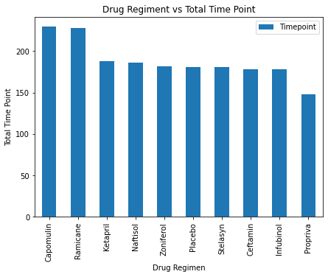

Based on the above graph, the Capomulin regiment and Ramicane regiment have higher total time point than other drugs treatment.

1. 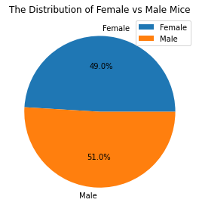**The distribution of Female and Male study mice:**

Based on this pie chart, the percentage of female mice and male mice used in the trial treatment are almost the same. As a result, it can be said that the outcome of each drugs affected on each mouse gender would not cause much difference.

1. **The final tumour volume of each mouse across four regimens of interest**

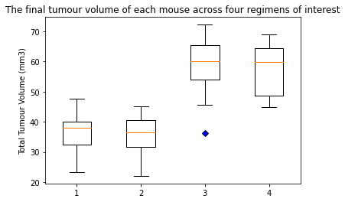

From the above diagram, there is some sort of movements in term of median of tumour volume from the 2nd regimens treatment and the 3rd treatment

1. **Average Tumour Volume vs Mouse Weight for Capomulin Regimen:**

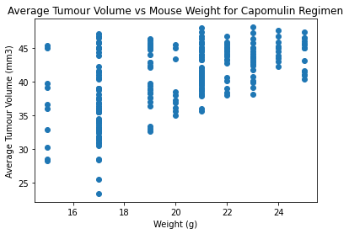

In overall, there was some sort of movement in weight as the average tumour volume increased. However, this indication was not quite well presented because some mice had low weight but the average tumour volume received were very high.

1. **Capomulin treatment of mouse l509**

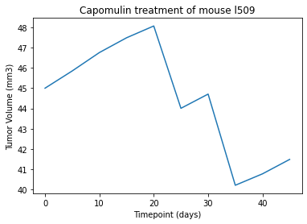

Picking up a random mouse l509 in the list of mice received Capomulin treatment, at first, the line increased as the amount of tumour volume increased over the number of treatment days. However, after it reached to the peak point (about 20 days), it started to go downward overall and then bounced back slowly after approximate 35 days. As a result, it can be said that during the first stage, a mouse l509 developed a large amount of tumour volume over a period of time. However, after about 20 days, the tumour volume started to decrease (although there was some up and down in between). It looked like the Capomulin treatment got some sort of affection to a mouse

1. **Correlation Coefficient:**

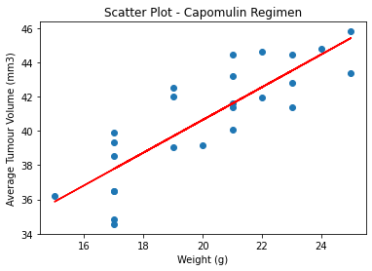

There was quite strong correlation coefficient (0.84) between the mouse weight and the average tumour volume. Besides, based on the linear regression line, there was an upward trend movement under the Capomulin treatment.